LAS VEGAS · CHAPTER 092 · REGION X · EST. 1962

 | September 2026

SONEAIR NEWS
The Newsletter of ASHRAE of Southern Nevada

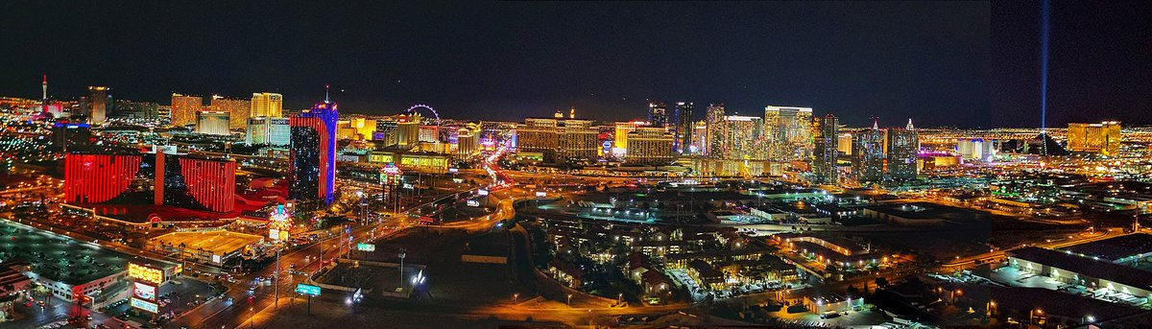

2026–27 Society Theme
“Changing the Game: Retrofitting for Resilience”
“Today, we’re facing one of the greatest challenges of our time: climate change. As we work toward a more sustainable future, we need to figure out how Team ASHRAE, with its wealth of knowledge and educational offerings, can help create a game plan to make existing buildings more efficient, healthy and resilient.”
— Sarah E. Maston, P.E., BCxP, LEED AP · ASHRAE President 2026–27

In This Issue  President’s Message Welcome to the new ASHRAE year — from Chad Langille.  Your 2026–27 Board Officers, chairs and the Board of Governors.  Chapter Calendar Eight programs. The year is booked.  September Luncheon Register now — Nick Mastrion, CEM, CMVP, at Sierra Gold.  Southern Nevada at the CRC The awards, and why it matters.  Inside the Rooms Highlights from the sessions and votes.  Order of the Engineer The ring — plus a look at CRC 2027.  History Corner September 1996 — the Sands and SONEAIR.  Chapter Sponsors Silver, Gold and Platinum — open. | ON THE STRIP THIS YEAR  Sep 17 Beers with the Board · First drink on us  Sep 22 Luncheon · 11:30 · Nick Mastrion  Oct 27 Luncheon · Bruce Lindsay  Nov 6 Golf · Sold out — waitlist open  Dec 3–4 Holiday Party  Jan 19 Luncheon · Matthew Smith  Feb 16 Luncheon · Data Centers  Mar 23 Dinner · Past Presidents Night  Apr 20 Luncheon · SNWA Moratorium  Monthly meetings at Sierra Gold, 6515 S. Jones Blvd. Doors 11:30 a.m.  Full calendar on page 4.

From the President
Welcome to the 2026–27 ASHRAE Year
Southern Nevada Chapter Members,
Welcome to the 2026–27 ASHRAE year. Our chapter has been serving the Las Vegas Valley since the early 1960s, and this year we step into Society President Sarah Maston’s theme, “Changing the Game: Retrofitting for Resilience,” with a full slate of programs, a new Board of Governors and real momentum coming out of the Region X CRC.
That theme could not fit Southern Nevada better. The overwhelming majority of the square footage in this valley is already built — resorts, hospitals, schools, data centers and industrial facilities designed for a different code cycle, a different load profile and a different water and energy reality. Retro-commissioning, controls upgrades, heat-pump and thermal-storage retrofits, and utility incentive programs are exactly where our members spend their days. Our program calendar this year was built around that work.
“The overwhelming majority of the square footage in this valley is already built.”
A few things worth celebrating as we open the year:
- We are proud of what Southern Nevada brought home from the CRC in Waikiki: Amber Aguilar received the Golden Gavel — Region X President of the Year. Melvin Berrios was named MP Chair of the Year and earned the Limelight and Blue Ribbon. Chapter Service Awards went to Amber, Michael Aslanides and Soren Peterson. Mark Baker is Top Chapter Historian. And we will host CRC 2027. Full report on pages 6–8.
- The program calendar is full. Every monthly meeting from September 2026 through April 2027 is scheduled, and nearly every speaker is confirmed.
- The Annual Golf Tournament is November 6 — and foursomes are fully sold out. Two tee box sponsorships remain, and a waitlist is open for teams if a spot frees up. Contact Soren Peterson for either.
- Beers with the Board is back September 17 at WSKY — no agenda, no dues pitch, and the first drink is on ASHRAE. Hans Gottschaldt is your contact for this one.
- History Corner continues. After recovering the chapter archives and hosting our past presidents, every issue this year looks back. This month: September 1996.
- Sponsorship slots for the newsletter, luncheons and raffle prizes are open. Early supporters get the most visibility.
What we need from you is simple: show up, bring a colleague who is not yet a member, and volunteer for one thing this year. Student Activities, Research Promotion, Membership Promotion and Government Affairs all have room.
Here’s to a strong 2026–27. We’ll see you on September 22.

Chad Langille
President, ASHRAE of Southern Nevada
Est. 1962 · Chapter 092 · Region X · Las Vegas, Nevada · ashraesn.com

Chapter Leadership
Your 2026–27 Board
Please welcome the officers, chairs and governors leading ASHRAE of Southern Nevada this society year. Every name below is a representative of this chapter and every address is a working one — a question, a program idea, a sponsorship, or an offer to volunteer, send it straight to the person who handles it.
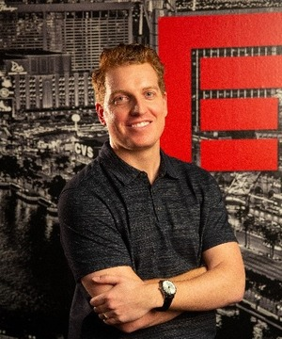  Chad Langille  President | 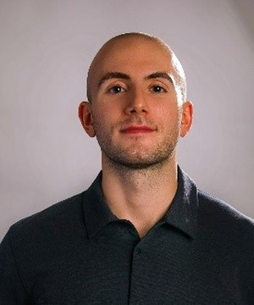  Sebastian Mijaica  President Elect | 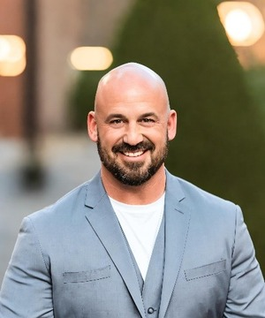  Hans Gottschaldt  Treasurer |   Rob Warnell  Secretary

Officers & Chairs — 2026–27  President Chad Langille  clangille@fealasvegas.com  President Elect Sebastian Mijaica  smijaica@airtreatment.com  Treasurer Hans Gottschaldt  hgottschaldt@accoes.com  Secretary / CTTC Chair Rob Warnell  Rob.warnell@airhydronicspecialties.com  Past President (P²) / YEA Co-Chair Amber Aguilar  aaguilar@airtelligence.com  MP Chair Ryland Whitaker  ryland.whitaker@trane.com  RP Chair / DEI Chair Jason Reese  jreese@innovanv.com  YEA Chair Sebastian Mijaica  smijaica@airtreatment.com  Historian Mark Baker  mark.r.baker@effem.com  GA Chair / Refrigeration Chair (P²) Hugh Tanner  htanner@lorencook.com | Chairs & Board of Governors  Golf Chair (P²) Jeron Hogan  jeron.michael.hogan@jci.com  Golf Co-Chair (P²) Soren Peterson  soren@engin8.com  SA Chair (P²) Keaton Frerker  kfrerker@mpnevada.com  CTTC Co-Chair Haneef Ahmed  Haneef.ahmed@airhydronicspecialties.com  SA Co-Chair Rick Parsley  rparsley@airtelligence.com  BOG (P²) John Bowman  JBowman@norman-wright.com  BOG Paul Salisbury  paulsalisbury@coreconstruction.com  BOG Melvin Berrios  melvin@metermanhvac.com  BOG Michael Aslanides  maslanides@lmses.com  BOG Pete Quiroz  Pete.Quiroz@nv5.com

P² marks a past chapter president. CTTC is Chapter Technology Transfer. GA is Government Affairs. MP is Membership Promotion. RP is Research Promotion. SA is Student Activities. YEA is Young Engineers in ASHRAE. DEI is Diversity, Equity and Inclusion. Want in? Talk to any name on this page, or find Hans at Beers with the Board on September 17.

Mark Your Calendar
2026–27 Chapter Calendar
The year is booked. Monthly luncheons and the March dinner are at Sierra Gold, 6515 S. Jones Blvd., Las Vegas. Doors typically 11:30 a.m. Register for September 22 at ashraesn.starchapter.com. Seats at Past Presidents Night and the holiday event go fast.
Date | Status | Format | Topic | Speaker
Tue, Sept. 22 | Confirmed | Lunch | HVAC Energy Efficiency Opportunities for NV Energy Incentives | Nick Mastrion
Tue, Oct. 27 | Confirmed | Lunch | ICE — Resiliency & Thermal Storage | Bruce Lindsay
Fri, Nov. 6 | Confirmed | Golf | Annual Chapter Golf Tournament | —
Thu/Fri, Dec. 3–4 | Save the date | Holiday | Chapter Holiday Event | —
Tue, Jan. 19 | Confirmed | Lunch | Air-Cooled Heat Pump Chiller Best Design Practices | Matthew Smith
Tue, Feb. 16 | Confirmed | Lunch | Data Center Introduction | Justin Veilleux
Tue, Mar. 23 | Scheduled | Dinner | Past Presidents Night — History of Las Vegas Architecture & Mechanical Engineering | Rob Finnegan
Tue, Apr. 20 | Scheduled | Lunch | SNWA Moratorium Update | Mike Bernardo

March 23 is Past Presidents Night — bring a past president if you can. Topics and speakers current as of publication; watch chapter email for times and registration.
Beers with the Board  September 17, 2026 · 3:30–5:30 pm  WSKY Bar + Grill  5560 W. Warm Springs Rd., Las Vegas  The first drink is on ASHRAE.  Contact: Hans Gottschaldt, Treasurer | Annual Golf Tournament  Friday, November 6, 2026  SOLD OUT of foursomes. 2 tee box sponsorships left.  Waitlist open if a foursome drops.  Soren Peterson · soren@engin8.com | Sponsor a Luncheon  Be our next RP sponsor.  Donate two or more raffle prizes.  jreese@innovanv.com

Kick Off the Year · Thursday, September 17
Beers with the Board
“The First Drink Is on ASHRAE.”
Before the first luncheon, before the first invoice, before anybody asks you for anything — come have a beer with us. 3:30 to 5:30 p.m. at WSKY Bar + Grill, 5560 W. Warm Springs Rd. No agenda. No presentation. No dues pitch. Just the people who run this chapter, in one room, easy to talk to.
This is the single best place to ask the question you have been sitting on — how do I get a PDH, how do I get my company in front of this room, how do I get on a committee, is ASHRAE worth it for someone at my stage. Bring a coworker who has never come to anything. First-timers, students and “I used to be a member” folks are exactly who we are hoping to see. Find Hans Gottschaldt when you walk in and he will introduce you around.
The first drink is on ASHRAE.
Contact: Hans Gottschaldt, Treasurer · Show up. That is the whole ask.

Tuesday, September 22 · 11:30 a.m.–1:00 p.m. · Sierra Gold
Open the Season at Sierra Gold
HVAC Energy Efficiency Opportunities for NV Energy Incentives
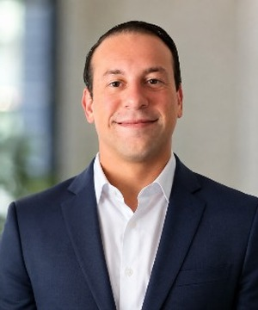  Nick Mastrion  CEM, CMVP | This is the first luncheon of the 2026–27 ASHRAE year — the one that sets the tone. Come hungry, bring a colleague who has never been, and stay after. Southern Nevada luncheons are technical, informal, and welcoming. If you have been away, this is the meeting to walk back in.  Nick Mastrion, CEM, CMVP, is the right person to open it. Seven years in energy analysis, project evaluation, utility-program implementation, and M&V. CEM is the Association of Energy Engineers’ flagship credential for people who run efficiency projects. CMVP is the measurement credential that keeps incentive claims honest. If you specify, sell, or operate HVAC in this valley, he is speaking your language.

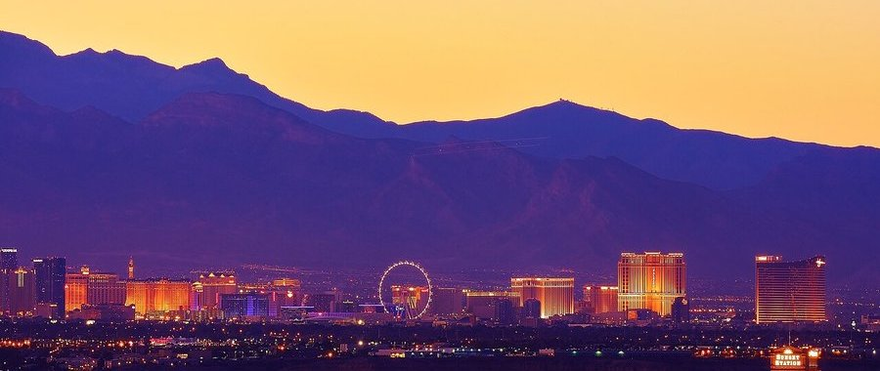

.
What you’ll take away
- Which HVAC measures currently qualify for NV Energy commercial incentives — and how the paperwork actually works.
- How control strategies, not just equipment swaps, drive measurable savings in existing buildings.
- How to build the incremental-cost case, and where M&V protects the incentive.
Register now — seats go first
ashraesn.starchapter.com/meet-reg1.php?id=184
Tuesday, September 22 · 11:30 a.m. to 1:00 p.m. · Sierra Gold, 6515 S. Jones Blvd., Las Vegas. Members, guests, students, first-timers — you are invited. This is the start of the season.

From ASHRAE — September 3 Industry News
California’s Heat Pump Access Act (SB 222) would require online automated permitting for residential heat-pump HVAC and water heaters, cap fees, and limit HOA rules that block replacing gas with electric. Enrolled for the Governor in late August. Not Nevada law — it is the West’s live experiment in faster heat-pump retrofits, which matters here as January’s program turns to heat-pump chiller design. Closer to home: a Nature Health study credited air conditioning with nearly 58,000 U.S. lives saved from 2010–2020, while IEA/UNEP project cooling electricity to triple. In this valley that is July — which is why NV Energy incentives sit at the center of this year’s calendar.

Waikiki · August 16–19, 2026 · Sheraton Waikiki
Southern Nevada at the CRC
Seven Board of Governors members represented Southern Nevada at the Region X & XI joint Chapters Regional Conference in Honolulu. What follows is what was said, what was decided, and what the chapter was recognized for — in a little more detail than a list of plaques.
Golden Gavel | Amber Aguilar — Region X President of the Year
MP Chair of the Year | Melvin Berrios
Limelight + Blue Ribbon | Melvin Berrios — Membership Promotion, highest PAOE
PAOE Special Citation | Southern Nevada Chapter · President Amber Aguilar
Chapter Service Awards | Amber Aguilar · Michael Aslanides · Soren Peterson
Top Chapter Historian | Mark Baker — tiki, certificate, and the slide
Research Promotion | Certificate of Achievement · Gold Treasury · Endowed Funds · Full Circle · Goal & Challenge · High Five · APEX

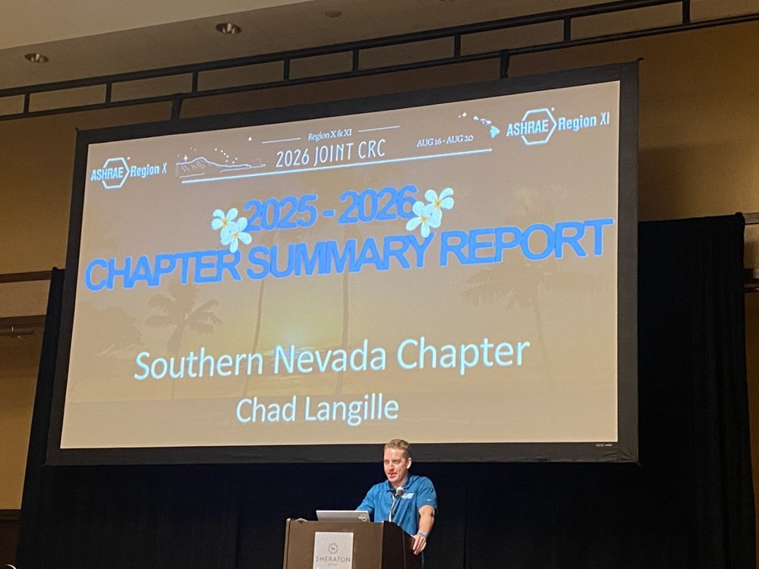  Chad Langille at the Sheraton podium — Southern Nevada’s chapter report, Region X & XI Joint CRC. | What the CRC actually is  CRC is the region’s annual working meeting. Four days, two regions, one hotel on Waikiki. Chapter reports run on a traffic-light clock — green to go, yellow for one minute, red to wrap. Workshops, a business meeting where motions actually get voted, an awards dinner, and this year an Order of the Engineer ceremony.  Chad presented our chapter summary from the podium. Amber accepted the Golden Gavel on stage. Being there matters — it is how a smaller chapter stays in the room when the region decides things, and how we bring the region’s ideas back to Las Vegas.

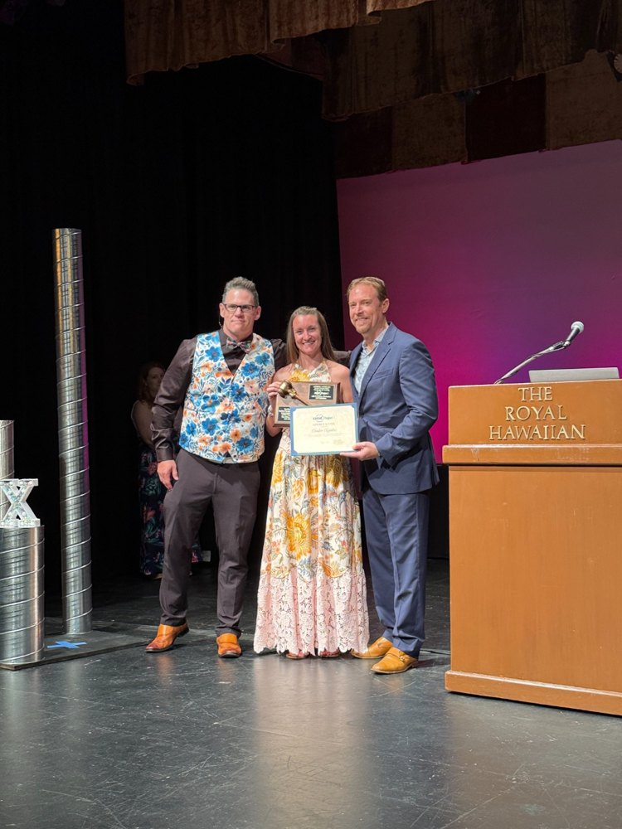  Golden Gavel, The Royal Hawaiian. | 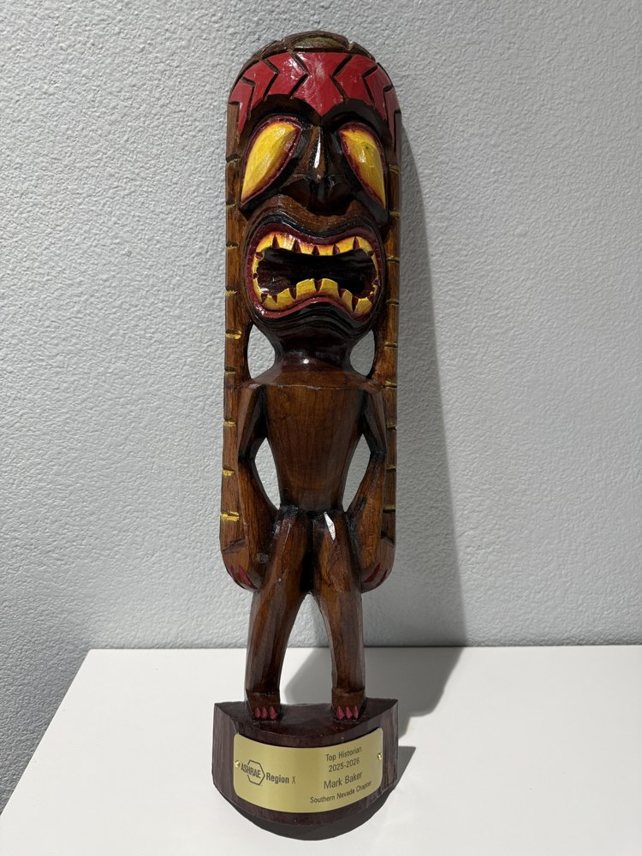  Mark Baker’s Top Historian tiki. | 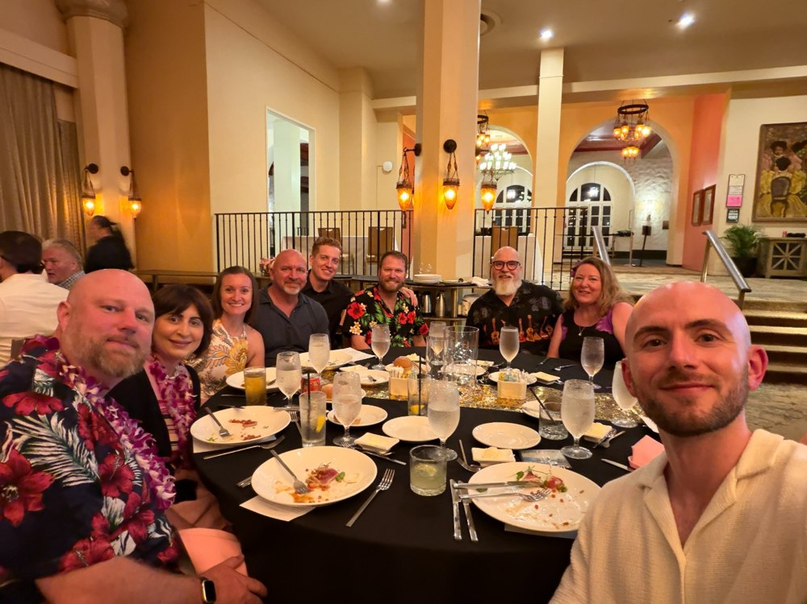  The Southern Nevada table.

Notes from the sessions
Inside the Rooms at CRC
Alex Barnes ran the chapter reports on a traffic-light clock and opened the data review with a useful caveat — “All models are wrong, some models are useful.” Devin opened the strategic-plan session with a story about reading the owner’s manual on his 1987 Suzuki Samurai: knowing how to operate something is different from knowing where you want to go. Below are the highlights we took away.
The business meeting  Votes worth knowing about  Region 10’s budget passed 13–0–1 at $116,200.29. Tucson’s motion created a Region X Hall of Fame, 14–0 — at most one recipient a year, and none if nobody earns it.  The chapter-dues question every metro chapter struggles with passed 8–6 once a $50,000 fiscal impact was attached, and now goes to the Society Rules Committee. A motion for single-sign-on access to standards failed 5–6–3 — standards remain read-only online, largely for legal reasons. | Programming ideas  What other chapters are doing  Golden Gate sold out a UCSF all-electric hospital tour in half an hour. Seattle borrowed Toronto’s Fight Night — four experts, one contested topic, audience picks the winner.  Tucson’s sporting clays event raised about $18,000, ahead of their golf tournament. Reminder: unused Distinguished Lecturer allocations return to the pool after November 1, so plan early. | From Society  AI, weather data, and decarbonization  Society is developing Ask Ray, a chatbot that answers from current ASHRAE documents using retrieval-augmented generation, plus generative-AI guidelines for members, likely first presented at the Chicago meeting.  The future-weather session noted that most design work still uses TMY files with data from 2005 or earlier. County-level future weather files from the national labs are available now, and a new ASHRAE guideline on using them is in draft.

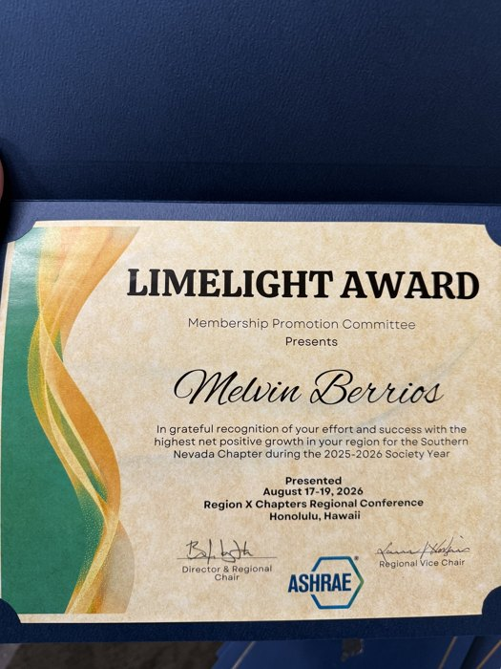  Limelight — Melvin Berrios, MP. | 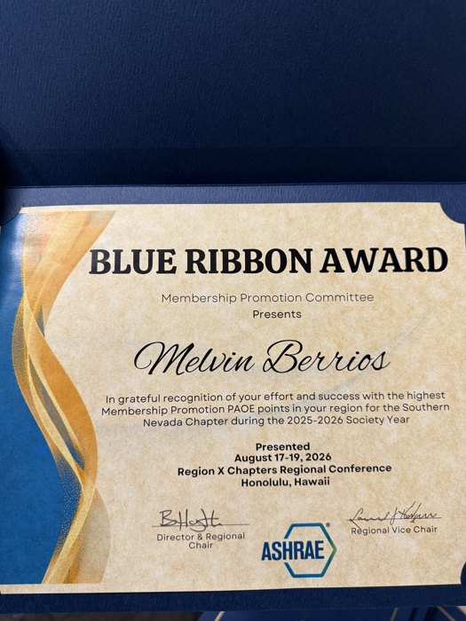  Blue Ribbon — highest MP PAOE. | 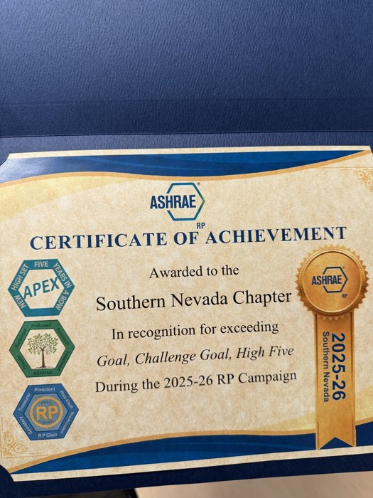  RP Certificate of Achievement. | 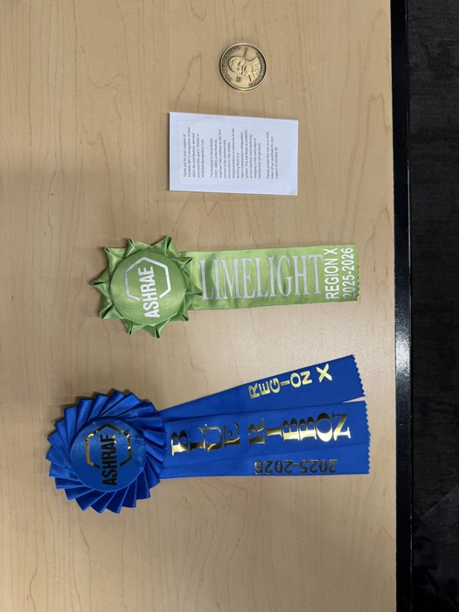  Limelight, Blue Ribbon, and the coin.

The ring ceremony — and a look ahead
The Order of the Engineer
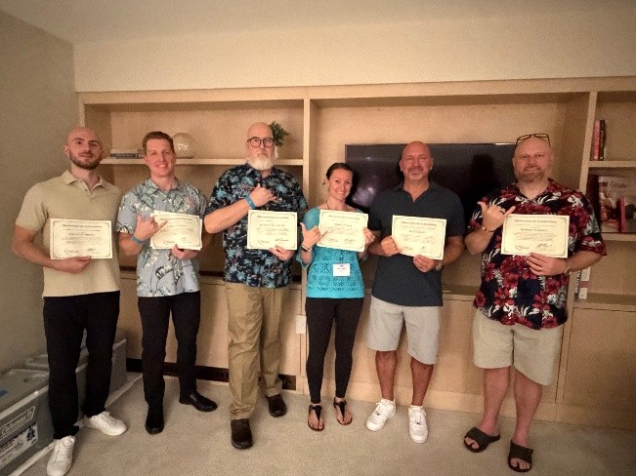  Certificates in hand — Order of the Engineer. | 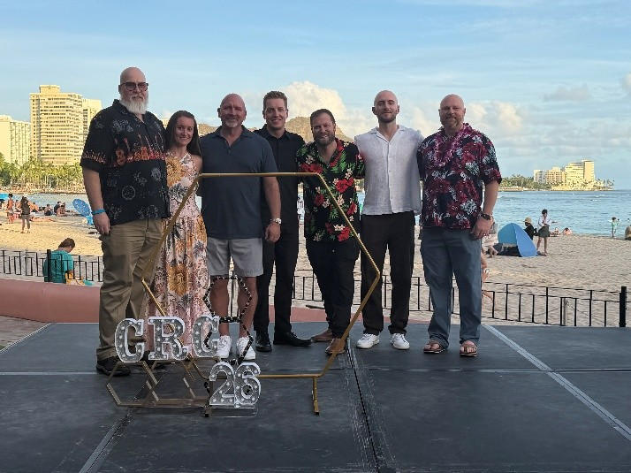  Seven BOG members made the trip. | 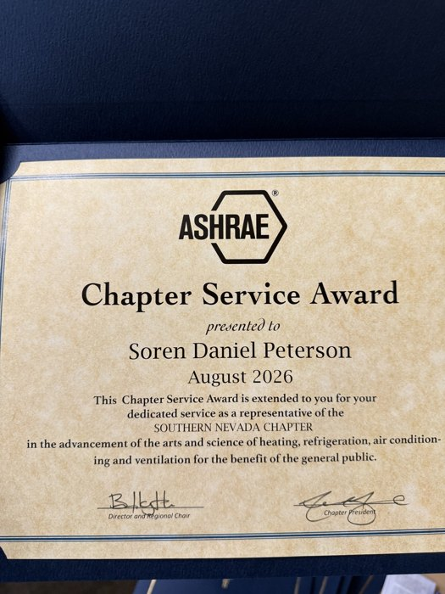  Chapter Service Award — Soren Peterson.

The Order of the Engineer
Several of the certificates in this issue came from the Order of the Engineer ring ceremony Region X hosted in Waikiki for anyone who wanted to take part — “You won’t find a better location,” the Region wrote beforehand. It was a warm and genuinely moving ceremony: engineers standing together, taking a public pledge, and putting on the ring.
The Order began in the United States on June 4, 1970, at Cleveland State, adapted from Canada’s 1920s Ritual of the Calling of an Engineer. No dues. No meetings. A lifelong pledge. You sign a certificate and wear a stainless-steel ring on the little finger of the working hand, where it hits the page every time you sign a drawing. Practice with integrity. Use Earth’s wealth well. Give your skill, when needed, for the public good.

Looking ahead: CRC 2027
Next year’s Chapters Regional Conference is Region X only — not joint — and Southern Nevada has the honor of hosting. Amber Aguilar is working with DRC Buzz Wright, and Tracey Jumper will co-chair. If you would like to join the host committee, tell Amber — a CRC on our home turf is a rare chance to welcome the region to Las Vegas.
If you would like to take the Obligation at a future ceremony, tell any board member — we will keep you posted.

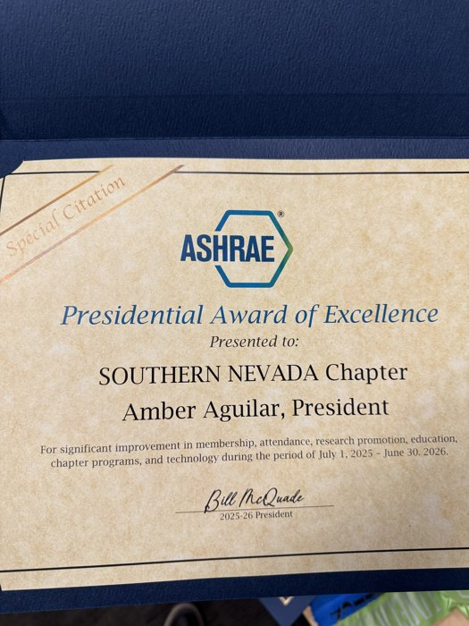  PAOE Special Citation — Amber Aguilar, signed by Society President Bill McQuade. | 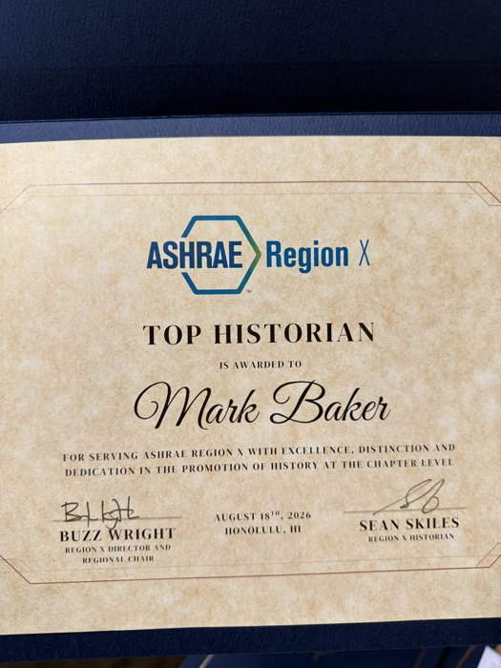  Top Historian certificate — Mark Baker, August 18, Honolulu.

History Corner · Las Vegas, 1996
When the Valley Changed Shape
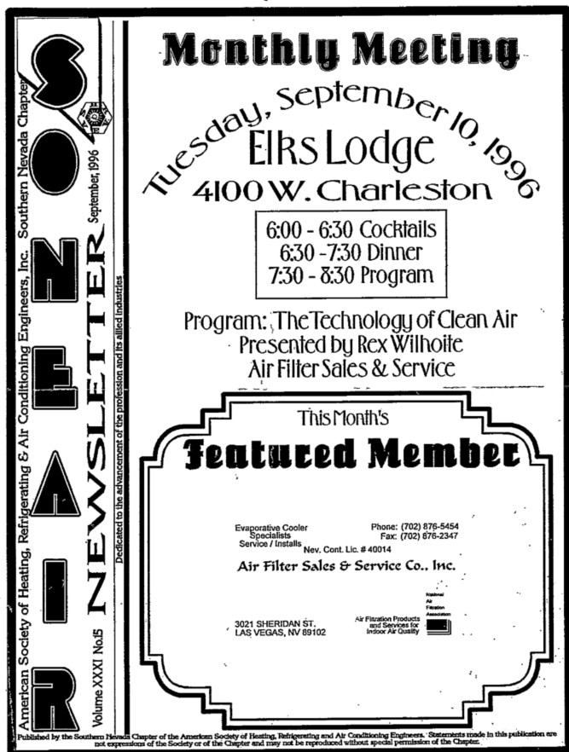  SONEAIR News, Vol. XXXI No. 5 — September 1996.  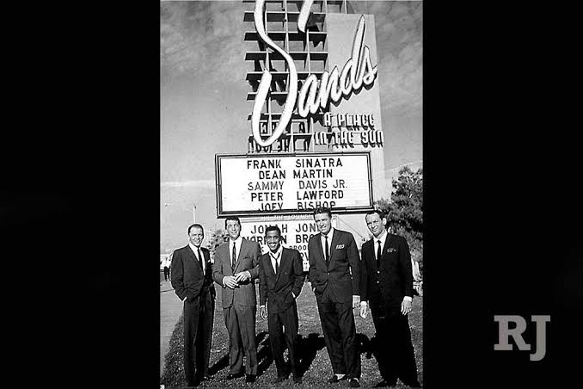  The Sands, in its Rat Pack years. | From the archives  A Look Back — 30 Years Ago  September 1996 excerpts from the chapter files, recovered after the chapter hosted its past presidents and rebuilt the archive.  Officers that year  President Clark McCarrell  President Elect Chris Sheldon  Secretary Pete Marcinkevich  Treasurer Dan Beck  Past President Arnold Lopez  The September 1996 program  Tuesday, September 10, 1996 at the Elks Lodge on W. Charleston: “An Update on HVAC Air Filters,” presented by Rex Wilhoite of Air Filter Sales & Service.  Thirty years later we are still arguing about filtration — only now it is MERV 13 in an existing air handler that was never sized for the pressure drop. Some things change; some things just get a new acronym. | Did You Know?  Vegas was building the future in September 1996.  UNLV broke ground on its new architecture building on September 4, 1996 — an $8.25 million, 75,000 square-foot facility, and a major investment in design, architecture, engineering and construction for Southern Nevada.  UNLV also hosted a science and engineering career event for women that fall.  And the Stratosphere opened, permanently redrawing the Las Vegas skyline.  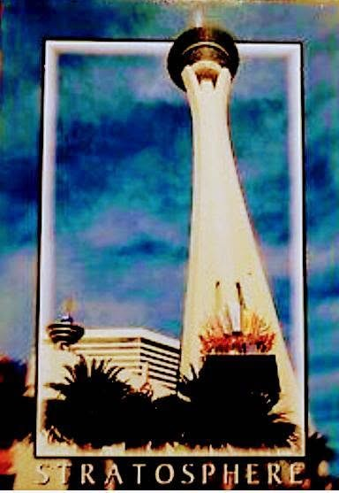

End of an Era: The Sands  The Sands, made famous by the Rat Pack through the 1950s and 1960s, was an icon in its time. Newer and more luxurious resorts eventually outshined it. The Sands was imploded in 1996 to make way for The Venetian — the city’s shift toward themed, destination-style resorts. Today The Venetian occupies most of the same land. Most of the signage went down with the building; one “Casino” sign survives on display in the Neon Boneyard. |   The Sands marquee, and the 1996 implosion.

Support the Chapter
Chapter Sponsors
The page is open. These spaces are reserved for the companies that step up to support ASHRAE of Southern Nevada this year — there is no better time to be first.
SPONSOR  Your logo here | SPONSOR  Your logo here | SPONSOR  Your logo here
SPONSOR  Your logo here | SPONSOR  Your logo here | SPONSOR  Your logo here

Levels of Sponsorship
Proceeds keep events affordable and fund ASHRAE research and student activities in Southern Nevada. Dollar figures and meeting-pass counts are proposed and subject to board confirmation.
Level | Investment | What you get
Silver | $500 | Name in SONEAIR News and on the chapter website. Name on the meeting display banner (small format, in person and on Zoom). No meeting passes. $515 by credit card.
Gold | $1,500 | Name and logo in SONEAIR News and on the chapter website. Name and logo on the sponsorship banner (medium format, in person and on Zoom). Includes 6 meeting passes. $1,545 by credit card.
Platinum | $3,000 | Name and logo in every SONEAIR News issue and on the chapter website. Large-format banner at meetings (in person and on Zoom). Bar-table signage at chapter socials. Includes 18 meeting passes. $3,090 by credit card.

Newsletter  Sebastian Mijaica · 702-722-8305 | Luncheon / RP  Jason Reese · jreese@innovanv.com | Golf · Nov 6  Sold out · 2 tee box sponsorships · Soren Peterson, soren@engin8.com

ASHRAE of Southern Nevada · Chapter 092, Region X · ashraesn.com · Las Vegas

